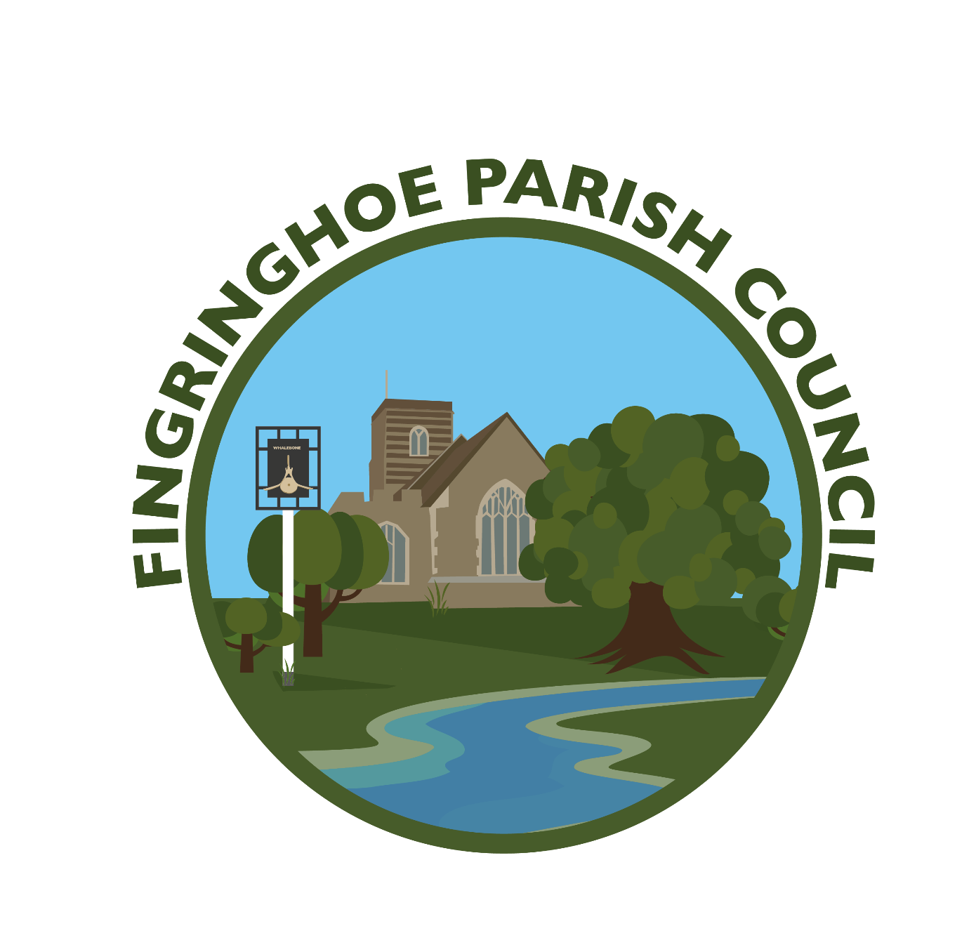
FINGRINGHOE PARISH COUNCIL
The Council will meet at the Village Hall, Chapel Road, Fingringhoe at 7pm on the following dates:
Tuesday 7th January 2025 Full Council meeting
Tuesday 4th February 2025 Full Council meeting
Tuesday 4 March 2025 Full Council meeting
Tuesday 1 April 2025 Annual Parish meeting
inc. Full Council meeting
Tuesday 6 May 2025 Annual meeting inc. Full Council meeting
Tuesday 3 June 2025 Full Council meeting
Tuesday 1 July 2025 Full Council meeting
August 2025 NO MEETING
Tuesday 2 September 2025 Full Council meeting
Tuesday 7 October 2025 Full Council meeting
Tuesday 4 November 2025 Full Council meeting
Tuesday 2 December 2025 Full Council meeting
Members of the press and public are invited to attend to listen or speak on matters relating to the agenda.
Petra Palfreyman Parish Clerk & Responsible Financial Officer Email: fingringhoeparishc@outlook.com Website: fingringhoepc.org.uk

