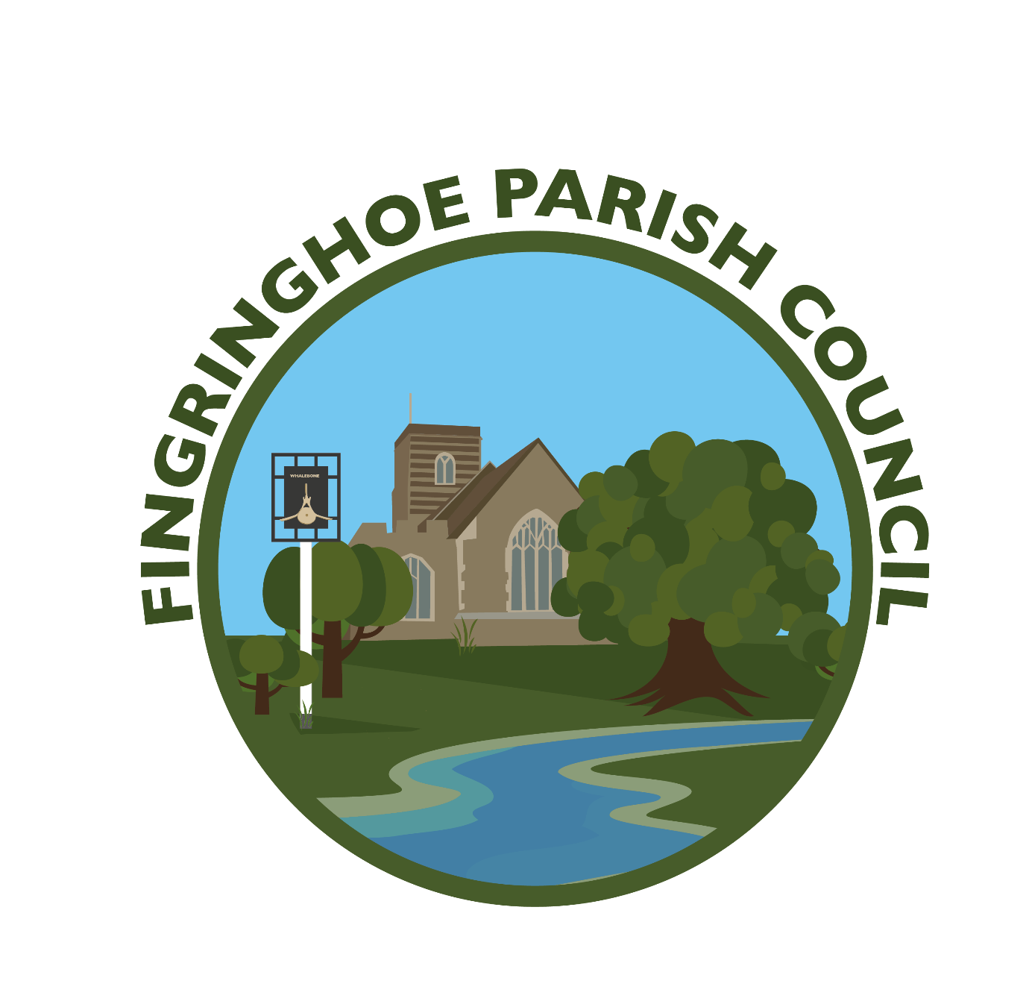
FINGRINGHOE PARISH COUNCIL
COUNCIL MEETING – 7th JANUARY 2025

A meeting of the Council took place at Fingringhoe Village Hall, Chapel Road, Fingringhoe, Colchester, Essex CO5 7BH on Tuesday 7th January 2025 at 7pm.

Councillors present: Gerald Ketley – Chairman
Sharron Law – Vice Chairman
Ian Chamberlain
Jonathan Martin
Petra Palfreyman – Parish Clerk

Also in attendance – Essex County Councillor Kevin Bentley, Colchester City Councillor Carl Powling and one member of the public.
001/25 Apologies for absence – Cllr Michael Clarke, Cllr Emma Dixon, Cllr Neil Gordon, CCC Cllr Dr
Martin Parsons and CCC Cllr Robert Davidson
002/25 To record declarations of interest – none
003/25 Public Questions – none
004/25 To receive reports from our Essex County and Colchester City Councillor
Cllr Bentley – Wished everyone a Happy New Year.
20mph project – Cllr Bentley will arrange a meeting with a Highways Officer to discuss how and if the 20mph speed limit can be put in place through the village.
The three tiers of councils in Essex will be reorganised into a two-tier system, to reduce
duplication, save money and improve connectivity. A Mayor will be elected with direct
powers and parish and town councils will have more devolved responsibilities and authority.
There will be a meeting later this week to decide whether or not to hold the May 2025
elections and have a combined authority, and an elected Mayor by 2026.
Cllr Powling
Wished everyone a Happy New Year from himself and Cllrs Davidson and Parsons.
Confirmed that the wheelie bins will go ahead next year.
005/25 To approve minutes of the meeting on 3rd December 2024 and any matters arising - the minutes as previously circulated were approved for signing. There were no matters arising.
006/25 To consider planning applications received
242434 2 Woodside Cottages, Haye Lane, Fingringhoe Colchester CO5 7AE Construction of two storey (self-build/custom build) dwelling house on land adjacent 2 Woodside Cottages Expiry date: 10/01/2025 No comments
007/25 To receive planning notification decisions
242122 South House Farm, South Green Road, Fingringhoe Essex CO5 7DP Side and rear extension to existing outhouse building and internal reconfiguration. Approve Conditional
008/25 FINANCE
- Accounts payable to 31 December 2024 – the following payments were noted and agreed.
Payment date | Payee | Purpose | Method | Total Amount  £ | VAT
18.12.24 | J Hawes & Son | Hedge cutting Dudley Rd | Bacs | 50.40 | 8.40
31.12.24 | P Palfreyman | December wages | Bacs | 492.80
31.12.24 | HMRC | Clerks PAYE | Bacs | 68.80
31.12.24 | Unity Trust Bank | Service charge | Bacs | 6.00
Total |  |  |  | 618.00 | 8.40

- To review the budget to 31 December 2024 – noted and agreed
- To note the bank reconciliation to 31 December 2024 – noted and agreed. The clerk also reported bank interest of £101.03 from the savings account
- To confirm the precept for 2025/2026 – following discussion it was agreed to increase the precept by 10.39% to £14500, plus £864 grant from Colchester City Council.
- To agree the Internal Auditor for year ending 31 March 2024 – a new internal auditor was agreed for 2024-25 at a cost of £200.00.

009/25 To review the quote for a new bench on Holmwood Farm and agree the next steps – the cost of a new bench would be £400. Following discussion, the Council agreed to repair the bench instead of replacing it.
010/25 Affordable Housing – to review the decision to look at potential sites around the village and decide the next steps. Following discussion, it was agreed to defer the decision again until more councillors are present and to ask the RCCE for more clarification.

011/25 To receive reports from Parish representatives
- Footpaths – nothing to report
- Village Pond - nothing to report
- Recreation Ground – Cllr Chamberlain to look at the play area fence posts
- Transport - nothing to report
- Fingringhoe School – nothing to report
012/25 Updates about ongoing issues
Common land – a land agent is looking into the boundaries and Land Registry
Bridge over spring at the pond – Cllr Chamberlain will repair this
Play area inspection report – no major issues. Cllr Chamberlain to report per 011/25
Bus stop – the clerk advised a grant is available for improvements to the bus service, but it was confirmed that the buses stop on demand through the village
Village name – the clerk is still receiving quotes for a stone name sign

013/25 Date of the next meeting – TUESDAY 4th FEBRUARY 2025 at 7pm at Fingringhoe Village Hall.

There being no further business, the meeting closed at 21.00pm

