ACCIDENT AT FINGRINGHOE
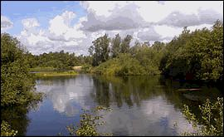
The following is from the Essex County Standard of August 30th 1946:-
" Six young soldiers, all members of the 15th Infantry Training Company stationed at Colchester were drowned when an assault boat capsized and sank at Fingringhoe.
They were members of a party of eight soldiers, who were engaged in carrying out a water-borne training operation in a water-filled quarry at Brook Hall Farm.
The dead men are Arthur Buckley (24), Samuel K. Govey (18), Raymond Edward Franklyn (18) {CWGC spells Franklin}, Richard Dennis Elliott (23), Eric Alfred Cook (18), and George William Butcher (22).
Two officers, who were directing the practice from the bank dived in fully clothed in a gallant attempt to save their men and they succeeded in rescuing two.
After dragging the gravel pit, members of the Essex Constabulary and soldiers recovered the last of the men late in the evening.
all the bodies were taken to St. Albright's Hospital, Stanway.
The collapsible wood-and- canvas military assault boat had just pushed off from the shore and when about 40 yards out became unbalanced, rocked violently and overturned.
The two officers grabbed the two nearest men and after helping them back to the bank, they returned in full battledress and for some time dived and searched. But they could not find the others.
The pit is the centre of a battle school area of some 60 acres and the Army took it over four years ago.
****************
One of the men, who was saved, Private Charles Joseph Gill, said he was in the stern of the boat. several men were standing until they were told by an officer to kneel. When the boat was about eight yards from the shore he heard someone say "The boat is sinking" and turning round saw water coming over the bows. The boat appeared to be collapsing.
Private Gill said he grabbed his rifle and the next thing he knew was that he was in the water with the rifle in his hand. He came up dropped his rifle, threw off his steel helmet and swam towards the bank. On the bank he removed his equipment and was taken to the Military Hospital. He had not previously been given instructions on how to behave in the boat.
Private John Donaldson, one of the party in the boat and who was standing in it helping to push the boat out, said "I had no chance to kneel down for the water quickly came into the boat when we were only a few yards out. The next thing was that I was in the water. I clutched the boat and another man came out and helped me to the side". He added that he had known weeks before that he would be going in one of the boats, but no one had ever told him what he had to do or how he had to behave when he got in the boat. "We were only told after we were in." he added.
Asked what he thought happened, Donaldson said, "I think it was the weight in the boat that caused it to capsize."
Captain Robert Rowe, the company commander, said the boat was moving stern first, and as it left the bank he shouted to three men who were standing to kneel down but they took no notice. "I kept on shouting" said the witness "and as the boat began to take water I could see it was going to capsize and I went into the water. I grabbed one but he went down and I went down with him. I took hold of him a second time but could not hold him and it was only with difficulty that I got back to the bank." Witness said he detailed a sergeant to see that two small holes in the boat were repaired before the exercise began. The sergeant reported that it had been done and the boat was paddled across once before it embarked.
Asked his opinion of the cause of the accident, Captain Rowe declared "Disobeying orders to kneel down and to the men panicking when the water came in.
Replying to the Coroner, witness agreed that no swimming instruction was given to the men. He had never seen a man stand before in the boats.
The Coroner: "If there had been no accident would you have had them on the mat for disobeying orders?" - "Yes"
Lieutenant Eric Perry, who had also entered the water in a rescue attempt said he grabbed Buckley, who was taken care of by Captain Rowe. "I then assisted Donaldson to the boat which was floating upside down," said witness "and by that time I was all-in and I only just managed to reach the bank myself."
Corporal Ronald Tilling, PT instructor, said he also entered the water and assisted two men to get out.
PC Webb said the pit was 100 yards square and varied in depth from 2 ft to 10 ft. When he arrived four men were still missing. An examination of the boat revealed that a wooden strut was missing from the port side. Rescue work was difficult owing to the amount of weeds.
After this evidence the Coroner accompanied by Captain Harold Hartley of the Royal Engineers and other witnesses inspected the boat. Capt. Hartley, in evidence said in his opinion the absence of the back side struts of the boat in no way contributed to the accident.
The Coroner recorded a verdict of "Death by Misadventure".
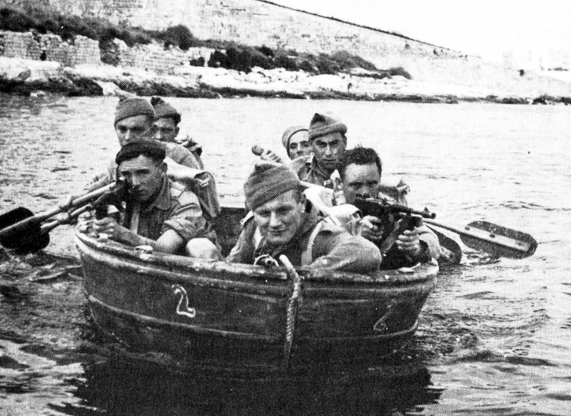
A Goatley boat of the type used at Fingringhoe, here seen at Malta

THE UNITED BENEFICE OF ABBERTON, EAST DONYLAND, FINGRINGHOE, LANGENHOE

