FINGRINGHOE’S HEROES

Dedicated to the Memory of our Fallen

There is just a list of names on Saint Andrew’s wall to record the passing of some of our young men from long ago. Those, who lost their lives in the service of our Country.

Many of their stories are harrowing, Read so that you may learn what they endured for us and know that if you shed a tear you do not weep alone.

ALEX CLOUGH RN H.M.S. "Pathfinder." 05/09/1914

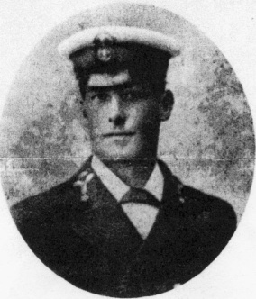
Alex was born & bred in the village. He settled here with his wife Lucy & seven children. He joined the Royal Navy in 1901 and serving on HMS Pathfinder became the first from the village to die on the 5th September 1914.HMS Pathfinder had been torpedoed by U.21 off the east coast of Scotland. She was so short of coal whilst on patrol that she could only manage a speed of 5 knots making her an easy target. She was the first British warship to be sunk by a torpedo. Out of the crew of 264 just 58 were saved

PERCY STUART RMLI H.M.S. "Pathfinder." 05/09/1914

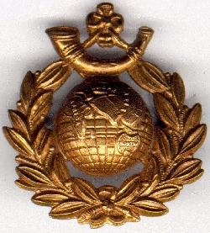
Percy was a regular serving in the Royal Marine Light Infantry. His mother was born in Fingringhoe & moved to Shoreditch. He too was lost in the sinking f HMS Pathfinder.

CLAUDE SAWKINS RN HMS Hawke 15/10/1914
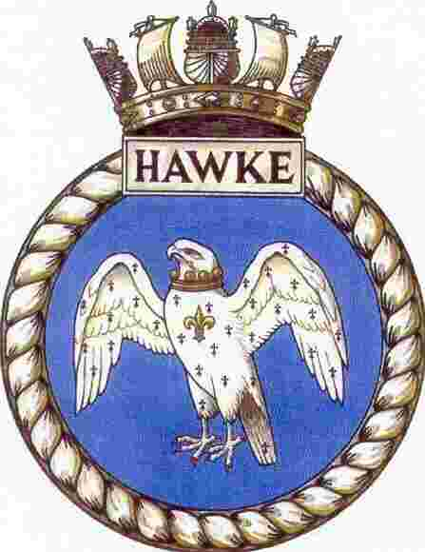
October 1914 saw the death of Claude, who had been born in Langenhoe but lived with his parents at Fingringhoe . He was a 17 year old boy seaman on H.M.S. Hawke. She was sailing with another old obsolete cruiser, H.M.S. Theseus in the North Sea. U-boat, U9 missed Theseus with a torpedo but with her second hit H.M.S. Hawke in the magazine. H.M.S. Hawke sank quickly and only managed to launch 1 lifeboat. H.M.S. Theseus was under orders from the Admiralty not to stop for survivors. Sadly a few weeks before H.M.S. Aboukir had been torpedoed and when H.M. Ships Cressy & Hogue had gone to her aid, they too in turn had been sunk. There were just 49 survivors from H.M.S. Hawke, sadly Claude was not among them.
PATRICK ROHAN King's Own Yorkshire Light Infantry 2nd Battalion 16/03/1915
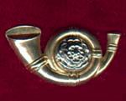
Patrick was from Ireland & married to Gertrude from the village. He was a Second Lieutenant serving as a regular with the 2nd Battalion of the King’s Own Yorkshire Light Infantry. They were one of the first units to land in France & were heavily involved in the early fighting at Mons and Le Cateau. He was killed 16th March 1915 in the build up for the Divisional attack on Hill 60 in April.

JOHN COOK Army Service Corps 18th Labour Coy. 13/08/1915
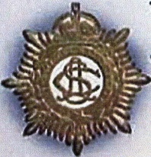
John was born at Fingringhoe & was living at Mistley. He joined the Army service Corps & was being shipped to Mudros for the Gallipoli campaign aboard the ill fated troopship Royal Edward. She was sighted by the submarine UB14 which fired one torpedo from under a mile away which hit her stern. The Royal Edward sank quickly. The after deck was awash in three minutes and the ship had sunk with her bows in the air in six minutes. There was heavy loss of life. Lloyds Register of Shipping states that" of the 1,586 on board less than 500 were rescued". Just before the attack the troops had carried out boat drill so when the torpedo struck many were below decks stowing their gear.
CLIFFORD BUCK South Staffordshire Regiment 8th Battalion 18/07/1916
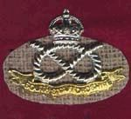
Clifford was born & living in Fingringhoe. His brothers Claude & Percy both were wounded while serving in the Rifle Brigade. His name is listed on the Memorial at St. Nicholas Tolleshunt D'Arcy. In this area 23 Boys from Tollesbury, the so called "Winkle Brigade", also joined the 8th Battalion of the South Staffordshire Regiment at the outbreak of war in 1914. He was wounded in the battle of the Somme & was brought home to die of his wounds at Wharncliffe War Hospital in Yorkshire.
JOHN FRANCIS Essex Regiment 11th Battalion 25/09/1916
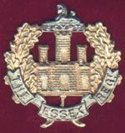
John was born at Elmstead & lived at Bourne Road. His name appears on a list of casualties held by Fingringhoe. He went to France at the end of August 1915 & was killed during the Somme Offensive the following year.

GEORGE GREEN Northamptonshire Regiment, 1st Battalion 28/09/1916
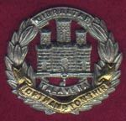
George was born in Thornham & lived in Fingringhoe with his mother Alice Buck. His Battalion was one of the first to move to France in 1914 7 took part in most of the subsequent actions involving the 1st Division. He died at the end of the Battle of Morval - 25th - 28th September 1916

The War Diary for the 1st Northamptonshire Regiment for the period shows:-
“South of High Wood 27th September 1916 - B & C Companies move up to FLERS Line and are placed at disposal of Officer Commanding 2nd Kings Royal Rifles. C Company attacked across the open between O. G. 1 & 2 with a view to taking a further portion of O. G. 1 while the 2/KRR assisted by bombers of our C Company made a bombing attack up O. G. 1 &2. There was no effective artillery preparation; the German trenches were strongly defended; the attack was unsuccessful. 2nd Lieutenant E. COLE killed, 2nd Lieutenant R. W. GATES wounded, about 30 Other Ranks killed and wounded “.( George was presumably one of those wounded dying the next day)
FRANCIS CARDEY Royal Sussex Regiment 2nd Battalion. 29/09/1916
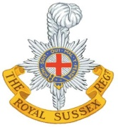
Frank was the son of Harry and Hannah Cardey, of Fingringhoe, Colchester, Essex. He had been living at Great Bromley in 1900 with his parents and 2 little sisters before they moved to Fingringhoe; their arrival being delayed because Frank had the measles. They lived in Hall Cottage below the churchyard; Mr Cardey worked at the Hall. Frank joined the Church Choir. He left school at 14 and was apprenticed to Mr. Hopwood, optician and clockmaker, of High Street, Colchester .He enlisted at Colchester and joined the Cyclists Battalion of the Essex Regiment but was sent to France with the 2nd Battalion Royal Sussex Regiment. He was wounded in the Battle of Flers-Courcelette. 15-22 Sep 1916 & died of those wounds on the29th.
HAROLD PARNELL Canadian Mounted Infantry 1/10/1916
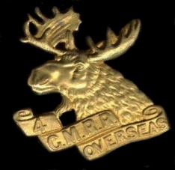
Harold was born in South Green, Fingringhoe 23rd March 1887. Son of Mrs. Fanny Parnell, of 18 West St., Colchester. At the time of the 1901 Census he lived in East Donyland & worked in a Boot Factory. He subsequently emigrated to Canada. He joined the 4th Canadian Mounted Rifles, which was formed at Toronto in Dec 1914 & attached to the 2nd Canadian Mounted Rifles Brigade. They arrived in France 24-10-1915. In 1916 “The 3rd Division's initiation to battle was even more devastating, for the Germans mounted a massive attack against their positions at Mount Sorrel. In the fierce bombardment, whole sections of trench were obliterated and the defending garrisons annihilated. The force of explosions hurled human bodies and even the trees of Sanctuary Wood into the air as the enemy succeeded in capturing the important vantage-points of Mount Sorrel and Hills 61 and 62. The 4th Canadian Mounted Rifles bore the brunt of losses: 89 per cent of its members became casualties. Of 702 soldiers, only 76 came through unscathed --On September 15, the 2nd and 3rd Divisions assaulted and captured the village of Courcelette. In the weeks that followed, the Canadians attacked again and again to advance only a few hundred metres over shell-pocked, corpse-strewn land. The deadly battlefield was crisscrossed by German defences” It was during this battle that Harold was killed.
DANIEL ABBOTT GREEN The King's (Liverpool) Regiment 1st Battalion 13/11/1916
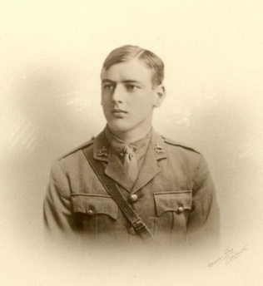
Daniel was the son of Daniel Abbott Green and Anna Maria Green, of East Donyland Hall, Colchester. Born 25/01/1895 in Fingringhoe Hall. Initially he enlisted in the 19th Royal Fusiliers, as a Private, serving in the19th (Service) Battalion (2nd Public Schools), which was formed at Epsom. This moved to France in November 1915 but was disbanded in 1916. Daniel received a commission & is shown in the Liverpool Regiment, as a Second Lieutenant serving with the 3rd Battalion but later attached to the 1st Battalion. This battalion had been in France since Daniel was drafted into replace those lost in the heavy fighting. The date of his transfer is not currently known, but the 1st Battalion with the 2nd Division was one of the first Divisions to move to France, the 2nd Division remained on the Western Front throughout the war. It took part in most of the major actions. His death coincides with The Battle of the Ancre - 13th - 18th November 1916. . He was killed leading his men on a night raid near Beaumont Hamel. His body was never found.
WILLIAM BAINES Essex Regiment 1st Battalion 14/04/1917
Son of Joseph and Mary Ann Baines, of The Foul, Blackheath, Colchester. 1901 census shows William Baines aged 5 born & living at Donyland listed as a Scholar. At the time of his death Blackheath was part of the Ecclesiastical Parish of Fingringhoe. His name appeared on a list of men, from the Parish of Fingringhoe who served in World War 1, which was originally held in Saint Andrew's Church. However, his name was not subsequently incorporated on the permanent memorial in the Church. He served in B Company 5 Platoon 1st Battalion (although originally joined the 11thBattalion) Born, Blackheath, Colchester,19/06/1895. He attended the Canterbury Road School, from 6/06/1903, previously at Old Heath School. He left school 11/06/1909 and joined the British Red Cross (reference Essex Museum records Inquiry List 08/1917). Unconfirmed family report that he perished when the Germans set fire to a cornfield in which he and some of his comrades had taken refuge. However, his death was in April and the corn was presumably un-harvested from the previous year. In fact there are reports of snow & it is possible they were victims of flame throwers.
ROBERT PAGE Essex Regiment 2nd Battalion 3/05/1917
Robert was born in Fingringhoe and lived at Bures in Suffolk. He enlisted, at Colchester. The Pages were active members of the church; some were church wardens and there is a family tomb in the Churchyard. at Saint Andrew's Fingringhoe. George Page, the father, left Fingringhoe to live in Bures, when the War Department bought Old West Farm in 1906. This farm had been the home to the Page family for generations from the mid 1700s. He was killed in action on the day after the 3rd Battle of the Scarpe - 3rd - 4th May 1917
ARTHUR SMITH Essex Regiment 9th Battalion 8/07/1917
Arthur was born in the Isle of Grain in Kent. Son of Mrs. W. Smith, of 49 Old Heath, Colchester. He lived in Fingringhoe & enlisted at Colchester. , His Division was not involved in a major action at the time of his death. He died of wounds.

JOSHUA FOOKES Royal Garrison Artillery 214th Siege Battery 27/07/1917
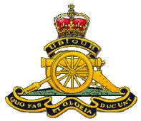
Joshua Fookes was known locally as "Bubs". He was born at the Forge on Pigsfoot Green and lived in Fingringhoe. Son of Thomas. and Emma Fookes, of Forge, Fingringhoe. He used to blow the organ in Church every Sunday. He enlisted at Colchester at the outbreak of war. He and a group of young friends, some only 16, went to the Recruiting Office at the Hythe. The sergeant told them to go home to their mothers. Joshua, of a quick and independent turn of mind, replied that he had volunteered, and now if the Army ever wanted him, they must force him to go. For a while he was exempted because of his trade, but was eventually sent to France with the Royal Garrison Artillery. Within three months he was dead killed with the others of his gun crew by a direct hit.
SAMUEL COLLISON South Staffordshire Regiment 7th Battalion 17/08/1917
Samuel’s mother was Emma born at Peldon & father Archibald Collison born East Donyland living at Fingringhoe working as a Farm Labourer. The last major action before his death involving his Division was the Battle of Langemarck 16-18th August 1917. He was killed in action

WILLIAM WATSHAM Manchester Regiment 19th Battalion 27/08/1917
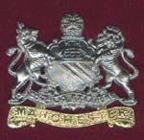
He was the son of William and Esther Watsham, of Fingringhoe Haye, Colchester. The family came to Fingringhoe round about 1825, when John Watsham and Maria Clark, both born in Alresford, and who had been married at Langenhoe in 1825, settled in the village. Most members of the family seem to have lived at The Haye. His regiment moved to France in November 1915. It served on the Western Front with distinction throughout the war. The Battle of Pilckem was fought by this Division between 31st July & 2nd August 1917. He did not die from enemy action but due to illness.

HAROLD NICHOLAS RN H.M.S. "Surprise." 23/12/1917
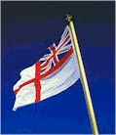
He was the son of Frank and Henrietta Nicholas, of Roman Hill Cottages, Berechurch, Colchester. note * the CWGC data bank lists him as Herbert Charles but this seems in error. His RN records show Harold Frank Nicholas born Fingringhoe 22nd June 1896. HMS Surprise along with HMS Tornado and HMS Torrent all British, R class Destroyers were mined in the North Sea whilst going to meet a convoy off the Maas light buoy . On the 23rd December 1917, "HMS Torrent" and her three destroyer division ran into a minefield. "Torrent" hit first, "Surprise" went to assist and was mined, and as "Tornado" tried to get clear, she detonated two mines and sank with only one survivor. Only "Radiant" got home. A total of 252 men were lost
ARTHUR WALKER Canadian Infantry (British Columbia Regt.) 14/02/1918
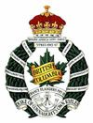
Arthur was known by his second name Pelham. He was the son of the Rev. Charles Littlewood Walker and Mrs. Walker, of Colchester, England. The Reverend Walker was the vicar at Saint Andrew's Church Fingringhoe between 1889 and 1901. He died aged 46 in 1901. His wife predeceased him. He did much for the fabric of the Church and reorganized the Pelham was born 29th October 1890 and baptised 6th January 1891 by his father. He had an older brother Basil Edmund Charles Walker born 1st July 1889. Pelham had emigrated to Canada and was farming there. He lists his next of kin as an unmarried sister, Gladys. He was 5 foot 3 1/2 inches tall. He joined 18th August 1915, having previously had some Militia training with the Corps of Guides. They crossed to Europe in September 1915 & were involved in some 12 major actions prior to his death. General Sir Arthur Currie, the commander of the Canadian Corps from April 1917 until the end of the war said, "In no battle did the Corps ever fail to take its objective, nor did it lose an inch of ground, once that ground was consolidated; and in the 51 months that it had been in the field the Canadian Corps has never lost a single gun (i.e. no piece of artillery was captured) I think one cannot be accused of immodesty in claiming that the record is somewhat unique in the history of the world's campaigns". Truly remarkable, but with great cost - over 54,000 were killed, 126,000 were wounded and over 4,400 were never accounted for.
FREDERICK TRORY 4th (Royal Irish) Dragoon Guards 22/03/1918
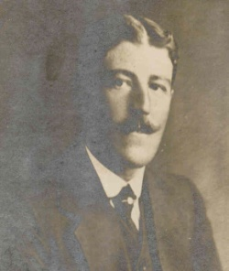
Frederick married Matilda CRICKMAR at St Andrews church, Fingringhoe on 28th April 1914. She was aged 35, a spinster, born in Fingringhoe, and had been a lady's maid in London. She was one of nine children. On their marriage certificate, Frederick states he is an RSPCA Inspector. They lived at Myrtle Villa, Fingringhoe, Colchester. He must have signed up with the 4th Dragoons, gone to France only four months after his marriage (The Mons Star). However, he must have been in England for a while from February 1915 onwards because his only son was born on 28th November 1915 in Newport, Monmouthshire. His name was Frederick Henry TRORY. It is doubtful whether Frederick senior saw his baby son more than a couple of times. He was killed in action on the second day of the last major German offensive “Operation Michael”. The Germans massed the Divisions freed from the Eastern Front by Russia’s surrender & threw them against the British in an attempt to knock Britain out of the war before America was able to make an impact.
WILLIAM NICHOLAS 4th (Queen's Own) Hussars 31/03/1918
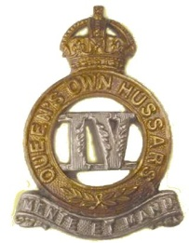
William was born at St. Botolph's & lived in Colchester. He enlisted at Warley. The family home was Roman Hill Cottages, Berechurch. His brother Harold was killed in the Royal Navy see above. In 1918, came the final German offensive launched on the 21st March, which hit the 4th Hussars at Compiegne on the Somme, costing the regiment 129 casualties in one week. On the 30th March the 4th, as part of the 3rd Cavalry Brigade they fought an important action at Moreuil Wood, stopping the advancing Germans from getting through the wood. The Commanding Officer, Lt Col Darley and sixteen others were killed before they were relieved by the infantry. William was one of these casualties.

CLIFFORD BAKER King's Royal Rifle Corps 12th Battalion 2/04/1918
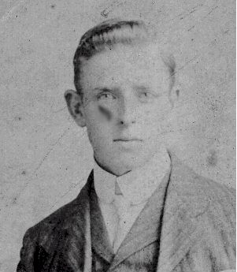
Clifford was the son of Henry and Ellen Baker, of Ferry Rd., Fingringhoe. He was born in Fingringhoe and enlisted at Colchester. He is commemorated on the Fingringhoe Methodist Chapel as well as Saint Andrew’s. The 12th Battalion was a service battalion heavily involved in blocking the German advance during “Operation Michael”. He died of wounds sustained in this fighting.

ALBERT MATHER Essex Regiment 9th Battalion 10/08/1918
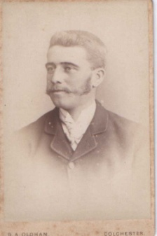
Albert was the son of Mr & Mrs J. Mather & lived in Fingringhoe. He enlisted at Colchester. Prior to enlisting, he had worked for Mr Roper at South Green Farm, Fingringhoe. He was killed in action during the Battle of Amiens. The artillery prepared with minimum registration, and laid down a fearsome creeping barrage. The assaulting infantry was deployed in great depth. Leading battalions were arrayed into 5 waves; the first guided the tanks and moved in two lines 30 yards apart. The leading units were supposed to stay close to the barrage, but the fog and smoke was so thick that in many places men could not see, only hear, the shell explosions. The second, third and fourth moved in single file, in small sections each thirty to sixty yards apart. Machine-guns, trench mortars and signals parties went with the fourth wave. At first they would follow tapes, laid out the night before, leading up to less than 300 yards from the front enemy positions. Behind came battalions in larger groups, disposed in a diamond, mopping up stragglers, neutralising strong points and taking prisoners into captivity. The total British casualties amounted to just over 22,200 of all ranks, killed, wounded and missing.
ARTHUR COOK Bedfordshire Regiment 2nd Battalion 18/09/1918
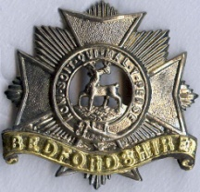
Arthur was born in Fingringhoe. He enlisted at Warley Barracks. Husband of Kate Ellen Cook, of 17, Charles St., Colchester. Before joining up he was employed at the Sanitary Authority's yard in Osborne Street. The Battalion remained in huts near Leuze Wood till September 16, when it embussed and went to a wood west of Aizecourt-Le-Bas, prior to taking part in the operations near Ronssoy in connection with a breaking of the Hindenburg Line.
At dusk on the 17th the Battalion moved to assembly positions west of Ronssoy. The Brigade plan was that the 7th Royal West Kents, who had been attached to our Brigade, were to advance eastwards and capture a line roughly two miles ahead. We were to follow, and in conjunction with the 24th Welsh Division on the right were to "attack, capture and consolidate the southern portion of the village of Ronssoy". The other two battalions of our Brigade, as soon as we had got to our objectives, were to form up to right angles to our advance and attack northwards.
At 5.20 a. m. the assault began; in the darkness the 7th Royal West Kents drifted slightly to the right, so that our leading companies, who were following in support, became involved in the fighting. Captain Gott's company specially distinguished itself by clearing a spinney where three machine-guns and 30 prisoners were captured and many killed. From here the leading companies were in touch with the enemy, and consequently were somewhat exhausted and reduced in strength on arrival at our correct jumping-off line.
The Battalion attacked in square formation, with C Company on the left and B Company on the right in front line, 2nd Tank Battalion, were of the greatest help in the village. .***
It was rather hard to count the exact number of prisoners we captured, as many were mopped up in conjunction with the 8th East Surrey Regiment, who passed through us at their zero hour. But it is estimated that our capture were about 400 Boche, 30 machine guns, 5 anti-tank rifles and 3 trench mortars.
Our parapet strength on the 18th (i.e. e. those who actually took part in the assault) is shown as 19 officers and 540 other ranks, and our casualties were 9 officers wounded, and among the other ranks 23 killed, 90 wounded and 6 missing***** Arthur was one of the 23 killed in action.
CHARLES COLTSON DSC RNAS & RAF 25/11/1918
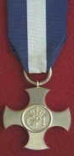
Son of the late Mrs. Ellis Reid (formerly Coltson), and stepson of the late Col. Ellis Ramsay Reid, C.B., D.S.O. , Accountant, Army Accounts Department, London and Chief Paymaster, Army Pay Department, of Blenheim, Colchester. His father had been originally the manager of the Bank of Africa at Maritzberg, South Africa He was an airship pilot in the Royal Naval Air Service. He received a Distinguished Service Cross while serving in the Navy for operations against submarines. During 1918 he transferred to RAF becoming an Honorary Captain the 1st April 1918. He was admitted to the Military Hospital at Devonport on the 20 November 1918 & reported to have died from influenza & pneumonia on the 25th November by Air Group Plymouth, which was his unit. He is shown on Fingringhoe’s list & Berechurch’s Memorial
WILLIAM RODGERS 24th Balloon Section RAF 3/02/1919
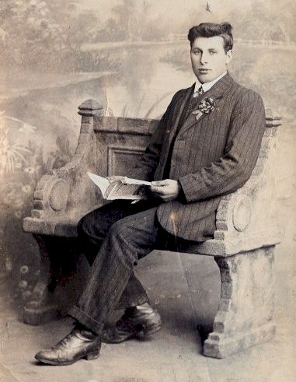
William joined the Army initially and was stationed at Harwich with his brother Robert in the forage section. They spent their time loading barges with hay for the horses on active duty in France. They had always been very close and both had experience in straw and hay cutting in their civilian life. Apparently William at some stage became homesick and wanted to see his mother back in Fingringhoe. One night he broke the curfew and cycled home to see her. He was later picked up by the Military Police and taken away. Shortly after this he was transferred for his sins to the Balloon section of the RFC over in occupied France. We believe he served out the rest of the war in this section. After the war, sadly he contracted pneumonia, probably not helped by the gas he must have been in contact with, and he died in February 1919.

REGINALD KING RN HMS "Ure" 14 /09/19
Husband of Edith M. King of Fingringhoe. He died on his return to civilian life, (In Memoriam Essex County Standard 18th September 1920). He is listed as returning from service in the Royal Navy on the Memorial list originally held in Saint Andrew's church, Fingringhoe. His grave was not listed as a Commonwealth War Grave.

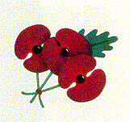
WORLD WAR 2
Twenty years later and the families had to face World War 2. There were no illusions. The parents knew war very well and now they had their sons and daughters in the Services. And they were at risk.
ALPHA WILKIN RN HMS Jupiter 10/03/1942
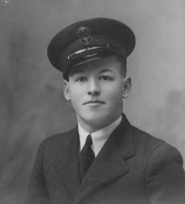
Alpha was a steward serving on a destroyer, H.M.S. Jupiter. H.M.S. Jupiter was in the thick of the action. The ship was involved in the evacuation from Norway, fights in the Channel, and action against destroyers in the Bay of Biscay. Bombardment of Genoa was followed by a transfer to the Med. Fleet. They had only been there a few weeks, when they were sent as escorts for H.M. Ships Prince of Wales & Repulse en-route for Singapore. They escorted the last convoy from Singapore, the last tankers to leave Sumatra and went back for the rearguard. They sank a Japanese submarine, which had been forced by a depth charge to the surface. As H.M.S. Jupiter closed with the damaged sub, the Japanese heroically tried to man their gun. As men were shot, others ran to take their place, until H.M.S Jupiter finally finished her with another depth charge. Only 2 Japanese survived. Then came the Battle of the Java Sea, with the loss of many Allied ships. During the withdrawal, H.M.S. Jupiter hit a mine and sank. Some made it ashore to Java. Those that were not in the first boats, were swept out to sea, as the tide changed. This group were ultimately captured except for Alpha, who died at sea 11 days later, still in the ship’s boats. The war had not finished with Alpha’s family. The Germans dropped a doddlebug in the field next to his home, so his parents had to move in with friends in the village.
HARRY HARRINGTON Essex Home Guard 7/6/1942
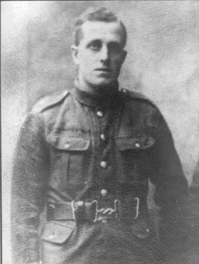
Harry served with the Royal Field Artillery, as a stretcher bearer, in World War 1& with the Essex Home Guard, Auxiliary 203 in World War 2. The Auxiliary 203 were a highly secret organization trained for sabotage & assassination of collaborators in the event Germany had invaded in 1940. They had secret underground bases with food & ammunition stores in several locations in Fingringhoe. At the time of his death, he was living at the Bungalow South Green, Fingringhoe. He died of Leukaemia and is buried at Fingringhoe. His son Bernard was killed as a POW a few weeks later.

JOHN MUMFORD RN H.M.S. Walney 08/11/1942
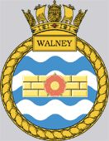
Son of Mr. and Mrs. P. F. Mumford, of Fingringhoe . He served as Petty Officer Telegraphist on a converted ex-US Coastguard cutter HMS Walney. Prior to "Operation Torch", the landings at Oran, HMS Walney had operated in the South Atlantic monitoring wireless communications between German U-boats and their supply vessels plus their Bases in Occupied Europe
HMS Walney was sunk by gunfire within Oran Harbour after first ramming both the outer and inner booms during "Operation Reservist", which was part of the “Torch Landings”
Walney was accompanied by her sister ship HMS Hartland in their attempt to capture the harbour. On board the Walney when she was sunk were 200 men of the 6th US Armoured Infantry Division and a 35-strong US Naval contingent under the command of Lieutenant Commander G. D. Dickey U. S.N. aboard, and 6 US Marines.
The French sloop La Surprise shelled her until the blazing hull capsized and sank. There were only 14 survivors from the crew of the Walney itself, one officer (Lt. Wallace Mosely R.N.) and 13 ratings. The commanding officer of the operation A/Captain Frederick Thornton Peters DSO, DSC. R.N. also survived. 81 of Walney's crew went down with the ship along with all but a few of the troops carried aboard.
The ships captain, Lieutenant Commander Peter Capel Meyrick R.N. was blown to bits on the bridge by a shell from a broadside, which also killed fifteen other officers and ratings gathered there. The only one to survive on the bridge was A/Captain Frederick Thornton Peters DSO, DSC. R.N. who was the Group Commander of the whole operation, who was in overall charge of both Cutters, the two ML's smoke-layers before breeching the booms, the various boarding parties and the landing of the troops. A/Captain Thornton Peters who although blinded in one eye survived the assault. (He was killed when returning to the UK from the operation in a plane crash). He was awarded a 'Victoria Cross' for his part in the operation.
BERNARD HARRINGTON Royal Artillery 67 (Suffolk) Medium Regiment 14/11/1942
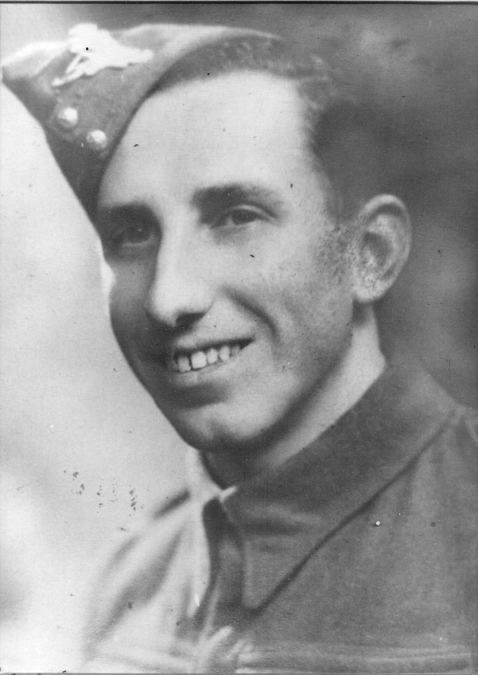
Bernard was born at Brook Hall Farm & lived in Fingringhoe. Son of Harry and Muriel Harrington. At the time of his death, his mother was a widow living at the Bungalow, South Green, Fingringhoe. He had been called up into the Royal Artillery at the age of 20 in 1940 and was transferred to the Middle East in 1941.
Bernard was captured along with John Hodson from Peldon at the fall of Tobruk and was being transported to Italy, as a POW by the Italian ship 'SS SCILLIN' (1903, 1579 BRT) some 10 miles north of Cape Milazzofrom on the voyage from Tripoli to Sicily when they where sunk by the British Submarine HMS SAHIB on the 14 November 1942 (Lt John Bromage). There where 815 Commonwealth prisoners of war aboard. Only 26 British P.O.Ws. and one South African was rescued + 35 members of the Italian crew, by HMS SAHIB. Both Bernard & John perished.
The following is an excerpt from a book "Copper Wire" by a RAF pilot Robert Harding taken prisoner by the Italians, which gives an account of the sinking of the SS Scillin :-
"The Italians were not fussy about how they transported prisoners from Libya to Italy. Often tramp steamers, which transported coal, munitions and war materials to Tripoli, were used to take live cargoes on the return trip. On these occasions, little regard was shown for the comfort or safety of the Prisoners of War, who were treated little better than animals. So it was with both those on The Scillin and, later, those of us on the final convoy to leave Tripoli. How very, very, fortunate I was not to have remained with the main body of prisoners who, on the 15th November, 1942, were taken to the Spanish Mole at Tripoli Harbour... On arrival they saw several ships at berth by the quay. One of these was a small coal-burning steamer of only 1,600 tons. This was the SS Scillin. After being kept standing on the quay for several hours, the prisoners were ordered to board the Scillin. Once on the deck, they were directed to the main hold from where two ladders led down into the dark. The hold was really only large enough to take about 300 men, if they were to be allowed to lie down during the three days of travel. But this did not deter the Italians. Although Captain Gilbert protested, more and more men were sent down the ladders. When 810 prisoners had been loaded, a halt was called. The men were then so tightly packed that no one could lie down...
The boat finally sailed on the evening of 15th November. (Another account says at 1pm on the 13th.) Either that night or shortly afterwards, the Scillin was attacked by a British submarine at about 20:30 hours. At that time Captain Gilbert was on deck treating some fifteen of the most seriously ill prisoners. Suddenly, out of the darkness, came a shell, which burst on the superstructure of the cargo boat. A second shell caused casualties. Then there was a violent explosion as a torpedo struck the Scillin in the hold carrying the prisoners. All on deck were thrown into the sea. Those below had no chance at all to escape. Captain Gilbert (the medical officer), Staff Sergeant Regester (a South African) and others were in the water for several minutes. The boat had sunk. Then the submarine, HMS Sahib or P212, came out of the darkness and began to pick up survivors. Reports from the submarine crew tell a little of what happened then. The captain, Lieutenant Bromage, and his men were astonished and deeply shocked to find so many men in the water.
One crew member is said to have shouted, “Any Englishmen in the water?” Back came the reply, “Nae, but there is a Scotsman!” The rescue went on for about half an hour before the Sahib was forced to retreat as an escort vessel approached. During that time 26 British and 35 Italians were rescued. Bromage and his crew were most upset by what had happened. However, the Scillin had been unmarked, in total darkness and had been carrying enemy materials. Later the Captain was absolved from all blame."
KENNETH CLEMENTS Naval Auxiliary Personnel HMS Dasher 27/07/1943
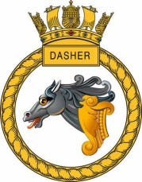
Ken was born 22nd June 1918 the son of George and Elsie Clements; husband of Queenie M. Clements, of Fingringhoe, Essex. He had been a member of the church choir from his youth. He had been a merchant seaman before the war. He was torpedoed three times & then found it difficult to get another ship, so had transferred to the Royal Navy. He served on HMS Dasher, which was an escort carrier converted from an ex-mercantile hull, the Rio de Janeiro, & transferred to the Royal Navy under lend lease. On the 8th November 1942 she was part of the "Operation Torch" Landings in North Africa. Her aircraft dropped propaganda leaflets over Oran. On her return to the UK she underwent repairs and modifications and rejoined the Home Fleet at Scapa Flow in February 1943. She sailed for Murmansk with convoy JW53 but, after only two days, was forced to turn back following heavy storm damage to her hull. After further repairs she was preparing to return to active service when, on 27 March 1943, she was lost in the Firth of Clyde following an aviation fuel explosion, sinking in 3 minutes with the loss of 27 officers and 331 ratings of her company.
CHARLES COOPER Suffolk Regiment 4th Battalion. 12/09/1943
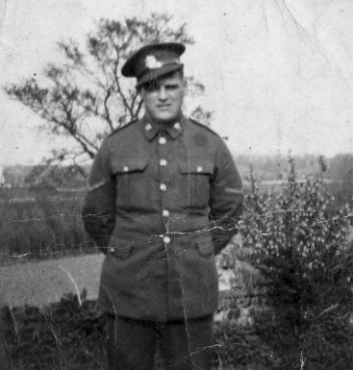
Charles Alfred Cooper and Frederick William were twins born 18 June 1917 at Wherstead, near Ipswich. They were sons of son of Mr. Arthur Cooper & and Mrs Martha Jessie Cooper. They moved to Fingringhoe about 1926 and lived in Ballast Quay Cottage. They attended Fingringhoe School & then Wivenhoe School. Unable to find work when they left school, both Charles & Fred joined the Army. Charles in the Suffolk Regiment & Fred in the RAOC.
The 4th and 5th Battalions of the Suffolk Regiment had a tragic time in the war.. Destined for Egypt, they were diverted to Singapore in a vain attempt to keep the British colony out of Japanese hands. One must remember that these two Battalions were essentially Territorials and new recruits with no battle experience. They were caught up in the surrender of Singapore and their war was spent enduring the brutality of the Japanese and Korean prison guards, over 4 years of torture, humiliation, starvation and disease.
Lance Corporal Cooper 4th Battalion died at Tarsao Camp which is on the Mee Khlong river north of Kanchanburi where he is buried. The Burma Thailand railway was completed as far as Tarsao in April 1943, this had caused enormous casualties mainly malaria, dysentery and beri-beri. In May, the 4th Battalion departed from Canburi to fill the gaps caused by this depletion of labour. They travelled by train to the railhead at Tarsao, crossing the terrifying newly constructed viaducts through the gorge of Wun Yi and Wun Po. As each half of the train reached the centre of the viaduct, it was stopped and the men had to get out and push. There were only sleepers on the track to stand on and a drop of 70 foot to the river below. The Battalion then marched for four days to Martona. Charles must have died at the railhead before the battalion moved on.

DENNIS WATSHAM RN HMS Bullen 6/12/1944
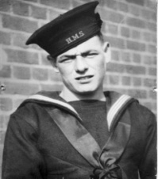
Dennis was the son of Jessie and Harold Watsham. His father, Harold Frederick Watsham (1896- c. 1945) was born in Fingringhoe. He had been a Private in the Essex Regiment in World War 1 and appears on the Fingringhoe list of those serving in that war. Harold married Jessie Cook in 1919 and the couple remained in the Colchester area and had eight children.
On joining the Royal Navy he was posted to HMS Ganges at Shotley . Having completed training he joined HMS Bullen. On 6 December 1944 at 0950, HMS Bullen was torpedoed amidships and sunk by U-775 west off Strathy Point, Scotland. She broke in two and sank about two hours later. Her Captain, Lt-Cdr A.H. Parish RN was lost with 71 of his crew, while 97 survivors were picked up by two other RN ships in company, HMS Goodall and HMS Hesperus.. Dennis was particularly unlucky as he made it to the deck with a good chance of being picked up but was killed when the jack staff fell on him.
CLAUDE SARGENT RAF 5007 Airfield Construction Squadron 24/07/1947
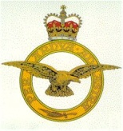
Claude our final story had been born at Fingringhoe but had married & settled in Lucas Road in Colchester. He had been trained as a barrage balloon operator & had been involved in the terrible air raids on Coventry. Although he had not been physically wounded he was hospitalised & ultimately died from shock in 1947.

YES, THEY WILL BE REMEMBERED.

These are short excerpts from their stories. More information is given in the Memorial Books held on permanent display at Saint Andrew’s ABBERTON with LANGENHOE.

Thursday, 13 May, 2010

