THE MEMORIAL BOOKS
These books contain the stories of those, who lost their lives in the service of their Country or through enemy action from the South Winstree peninsular, North East Essex.

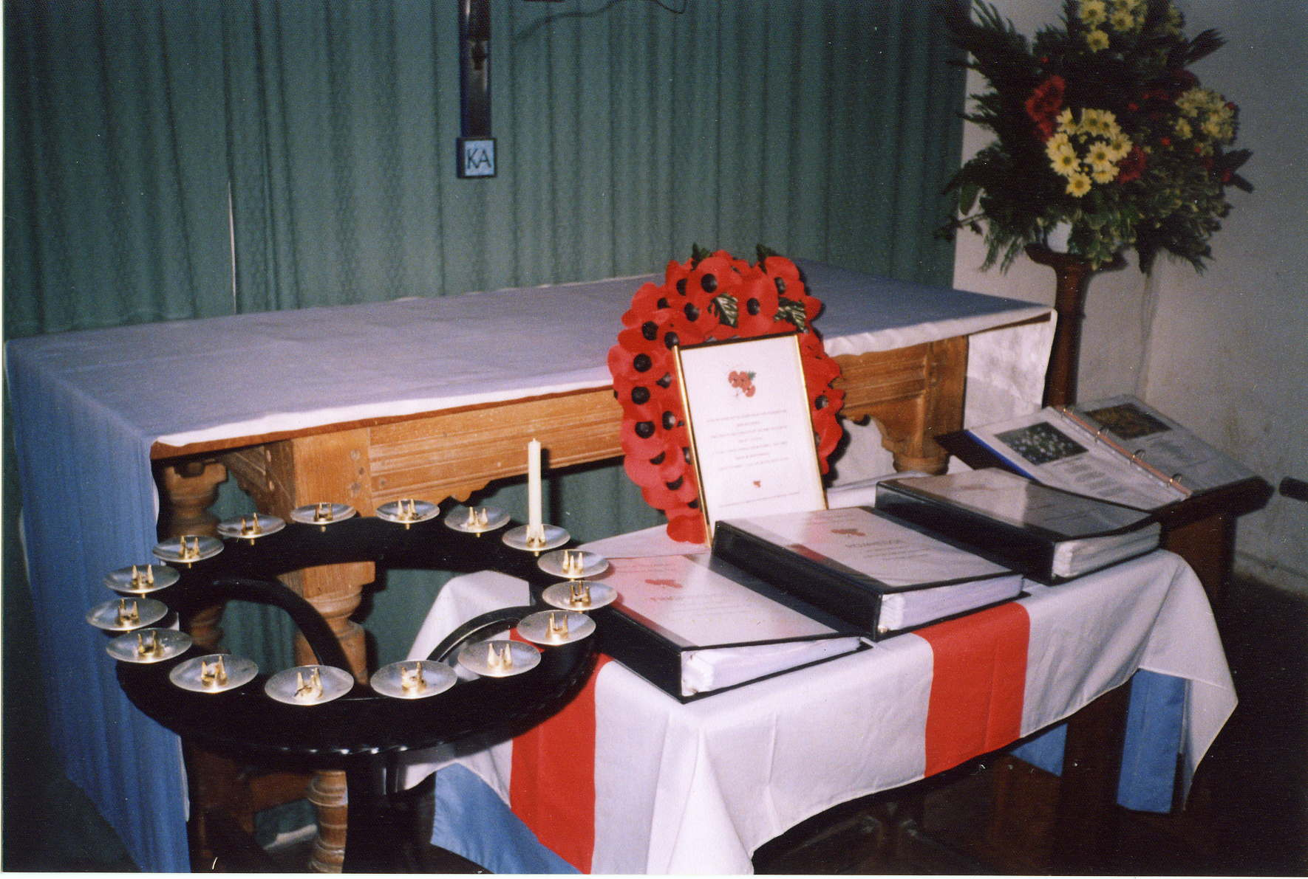
BACKGROUND TO THE PROJECT
There are now Memorial Books, giving some details of those who lost their lives in the Service of our Country, in the Churches at
 St. Andrew’s Abberton (for Abberton, Langenhoe, Fingringhoe & Rowhedge). There is also a book for those, who died in our villages.
 St. Mary’s Peldon (for Peldon & the Wigboroughs)
 St. Mary’s Salcott-cum-Virley
 St Mary’s Tollesbury. (for Tollesbury & the parishes of Tolleshunt D’Arcy, Knights & Major as well)
The project started at St Andrew’s, Abberton & Langenhoe, where a Memorial Stone was planned as part of a Millennium commemoration on the Village Green in 2000. There was doubt in the villages regarding whose name should be recorded and in the end the Parish Council settled on a general statement without any specific names. In parallel it was decided to put a Memorial book in the Church with such information as could be found on those who died. The book was made loose leaf with pages in clear plastic envelopes, so that additions & corrections can readily be made as extra information became available. The intent of the project was to allow people to sit quietly in the presence of God and learn about those that died.
There had been a partial list of 12 names previously on the church wall, which over the last few years has expanded to 30 to include others with equal claim to be represented. These other names came from a variety of sources including the Commonwealth War Graves Commission records, the CD Rom "Soldiers Died" & "Officers Died", and particularly from the local newspaper records held in Colchester Library. The criteria chosen was loss of life in the Service of their Country or through enemy action. Over the years this has included suicides suffering from shell shock and even a murder victim.
Initially there was a website hosted by Geocities but which has subsequently became abandoned & locked in cyberspace. It was still in existence in 2008 but contains some known errors and many omissions. The official latest version is the hard copy in the church.
Each man was accorded such details as are given in the CWGC records, his medal entitlement, details & pictures of him and his family plus such information as could be found from books, War Diaries, Ship’s logs, Regimental Associations or Museums etc relating to his service & death. In several cases we were greatly helped by people who had already researched their family trees.
PROGRESS TO DATE
A second book was displayed at St Andrew’s in 2001, containing the stories of those who died in our villages. During World War 2 the Battle of Britain was fought overhead and 2 RAF fighter pilots were lost; in the spirit of reconciliation 8 German airmen are also included. With the course of time many more names have been included in this book, as the other villages in the area were added; for example, 6 members of the Glosters drowned on a training exercise in 1947 in the gravel pits of what is now Fingringhoe Nature Reserve.
Abberton & Langenhoe share a Rector with Fingringhoe and Rowhedge (also known as East Donyland) in a United Benefice. Thus, in 2003, similar books were produced for these two parishes. The Rowhedge book also includes a petty officer killed on HMS London in the Yangtse incident. However, their churches are normally only open for services, so copies of their books are held at Abberton., which is kept open, albeit with CCTV installed in view of several thefts from the church.
In 2007 our neighbours at Peldon, Little & Great Wigborough also dedicated Memorial books, which are held at St Mary the Virgin at Peldon (42 names). Included is a casualty from the 1st Anglo-Boer War. This has been followed in 2008 by St Mary Salcott-cum-Virley (17 names) & St Mary Tollesbury (91 names).
Basically, the books now cover the area south of the Roman River to the Strood causeway, which connects to Mersea Island in the South; by the River Colne with Rowhedge in the East; while in the West by Abberton Reservoir plus the Blackwater with Tollesbury. Probably the total population at the start of the Great War was some 5000 souls, with Tollesbury and Rowhedge, being fishing ports, the main centres of population. Thus many of those lost served at sea. The others tended to be farm boys, many of them ending in Service Battalions to work with horses.
It is interesting that Rowhedge and Tollesbury also provided pre War crews for large racing yachts, including those owned by King George V and the Kaiser. When war broke out on the August Bank holiday 1914, many of the Tollesbury men were on yachts in the Baltic. They were given safe passage home by the Kaiser himself.
More recently two books covering the Blackheath area to the North have been added (124 names). These men were predominantly from Garrison families, whose descendants have moved from the area. Thus these entries tend to be only the basic information from the Commonwealth War Graves Commission records.
The parishes of Tolleshunt D’Arcy, Knights & Major are being combined in 2009 with Tollesbury thus their Memorial books have been added to those at St. Mary’s Tollesbury.
In all there are currently 450 profiles of those, who lost their lives in the service of their Country or through enemy action.
Finally, as those still alive who can actually remember the Fallen dwindle to a very few, we believe it important that we keep some knowledge of a time when relatives, friends & neighbours lost their lives in the cause of their country. The Abberton visitors book shows that over the past 9 years people from some 20 countries have visited this small church set in a farmyard. You too are cordially invited to visit our churches & to read the books where you may sit in the peace of God’s presence.
EASTER 2009

